Jan 4, 2023

Erie High School (EHS) Unified Sports
- Backpacks have been ordered. They indicate that the bags should be ready by mid-January. We will send out an email when the bags arrive and we can decide on a date for presenting the bags.
- We are going to support the team by attending the home games, if you are able.
- Bag tags have been ordered. Lori will take them to the InventHQ facility (Broomfield Library) and use the sublimation machine to transfer the Kiwanis International logo to one side and the EHS tiger logo and player number to the other side. The athletes will be able to keep their tag at the end of the season.

- 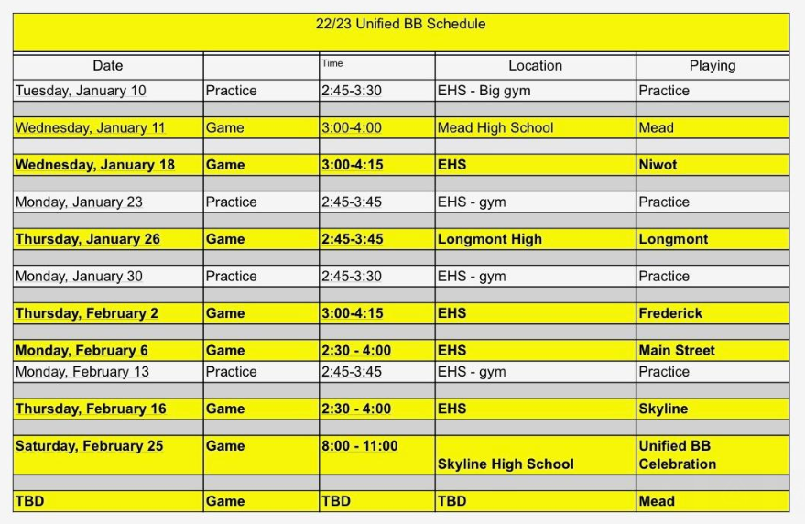
Red Hawk Robotics Tournament
- The tournament is being held on Saturday Jan. 14 at Red Hawk Elementary school. There are still volunteer opportunities. I will send a separate email with the links if you are interested in helping out.
Golf Tournament
- We discussed the possibility of hosting a golf tournament for fundraising purposes. Ryan has contacts at Colorado National. However, since our group is quite small, we would not be able to pull this off at this time. Possibly we could do this in the future.
Erie Tiger Network (ETN)
- Ryan is looking into the possibility of promoting our group through the Erie Tiger Network which broadcasts EHS sports and concerts on their YouTube channel.
- We discussed that it would be good to direct people to a website that would have information about our group as well as a link for people to donate money.
Next board meeting - Jan. 9 - Lori is attending

Next meeting - Jan 25

Members attending: Dale, Lori, Ryan, Jeff, Dave

