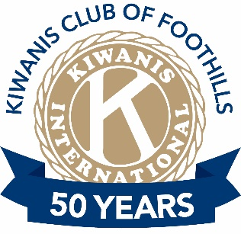

**July 31, 2023**

Kiwanis Club of the

Club Website: *www.foothillskiwanis.org*

**Meetings**: Mondays at 7:00 a.m. at the Brewing Market, 2770 Dagny Way, Lafayette, CO 80026, (720) 890-3993

***Snippets from Recent Club Programs***

Coming up . . .

**7/31/23** – James "Mac" McCarty; Betrayal of Benghazi

**8/7/23** – Board Meeting  
**8/14/23** – Jo Ann Joselyn: What's Happening in Sudan  
**8/21/23** – Gerry Morrell, Front Range Photography  
**8/28/23** – Report on DCON from attendees  
**9/4/23** – Round Table (meeting not formal convening)  
**9/11/23** – Board Meeting

**Program Chairpersons**:

July – Jim Bensman

August – Vince VanZago

September – Bob Mohling

**Upcoming Erie Satellite Meetings**, TBD, still looking for right time & place.

**KIWANIS: Serving the Children of the World!**



**President**

Matt Frederick

**Past President**

Bill Anderson

**President-Elect**

Bill Duclos

**Secretary**

Vince Van Zago

**Treasurer**

Joe Girard  
**Board of Directors**

Jim Bensman   
Alan Boeve  
Brian Coleman  
Craig Hurst

Bill Lester  
Lori McLean  
Annette Wagenknecht

**7/17/2023 – Greg Fickbohm—Louisville CO History**. , Greg is a decades long resident of Louisville with an appreciation for its interesting history. Greg has also worked many decades as a business manager, mostly for aerospace companies Ball and Bob Mohling's Technology Applications. He's now enjoying retirement. Greg attended the Air Force Academy earning a degree in Engineering Management.   
Louisville's "European" History begins in the mid to late 1870s as a home to, first the Welch Mine, and then many other coal mines. It offered a settlement for mine workers, most of them, at first, Italian immigrants.

Over time the mines began closing, the last in the 1950s. Then Louisville's role as a bedroom community, to Boulder and Denver, really began to take off. The recently completed Boulder-Denver Turnpike was a boon to this growth. [The McCaslin/Dillon Exit was completed in 1962. Until then the "Wadsworth" exit, with its toll booth and "Shep", was the only access. Pretty much doing this all off the top of my head, as no member took a photo of Greg or took notes at the meeting. I was out on travel]. In the late 1890s & early decades of the 20th century Louisville mines endured labor-owner conflicts, which also occurred in mines, fields and steel mills around the country. Its Italian culture is still extant, as shown by the many bocce courts; although downtown has lost its Italian restaurants.

**7/24/2023 – Steve Higgins and Allie Schmidt, HS Wealth Strategies**  
Steve and Allie are the principals of HSWS, a Goldilocks sized investment firm specializing in wealth accrual and management. They help manage our club's two investment funds: one for the Foundation and another for the Service Dog Program. I call them goldilocks as they are not super big, like Fisher, nor a small boutique outfit, where it might be a hobby. Their customer roll is intermediate sized (170 or so) so they can have a close relationship with each and every one.  
Their program allows different investment goals for each 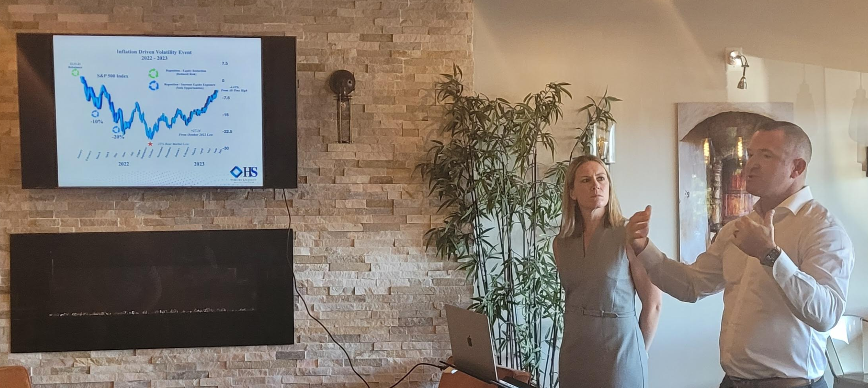customer, established through one-on-one interviews. Risk is managed by maintaining a liquid asset bucket on the low-risk side, and stocks (actually stock funds) on the other end.  
To protect against, and take advantage of, large market moves they do an asset rebalance of high/low risk when the market moves 10% with respect to its most recent high (they use S&P). This approach makes buying and selling positions very, very unemotional. They never try to "time" the market – a fools' errand every time. Large market movements can occur with little or no warning. It's been very beneficial to the club, and to my wife and me, as we are with them also. Recent large swings esp covid crash and inflation scares have actually turned out very well for their investors, and for us.  
We have some bonds with them too. These have always been short term (1-3 years) to remove interest rate risks. Sometime back before the Fed started jacking rates, HSWS moved us into even shorter-term bonds, on average <1 yr. Here they focus on dividends, not trading bonds.

**July Board Meeting, July 10**- 15 attendees, including 1 from Erie Satellite- New secretary needed for FY 23-24, beginning October 1.- We really need new club business cards with our Lafayette address (Brewing Market) for recruiting. I think Brian C took the lead.   
- We need a more permanent postal address, not just the - Secretary's (Vince is leaving the post) and Treasurer's. Paul Bailey has volunteered his own PO Box in Boulder.   
- Pam B requests more member support for the MyChoice Resource Center Fund Raising event: a clay shooting tournament.  
- Recruitment: Suggested we form an ad hoc committee to pick new meeting time (and place) to improve recruitment and retention.  
- Chamber of Commerce membership? Someone took the lead here, but I forgot to note it.

**Great News from Anthem Ranch.**Thanks to the legwork and recruiting efforts by our Foothills member **Jim Bensman** it looks likely that a new Kiwanis Club will be birthed in Anthem Ranch in the near future. Currently about 20 new member pledges; they will be a satellite of our club until they reach "charter strength." They have already been meeting in the Anthem Ranch Event Center for several weeks. Successfully sponsoring a new club is a very big deal in the Kiwanis World, for any club, let alone an individual. A happy update here: Jim will remain in our club. We look forward to working with Anthem Ranch on many future projects.

**KIWANIS: Serving the Children of the World!**

**Upcoming events and volunteer opportunities**

***Cool Dog Contest***: It's a **BIG** few weeks for our club. Contacting businesses, communities of all sorts, friends, neighbors and relatives to promote the Coolest Dog on the Front Range Contest. Our financial goals are lofty and it's gonna take a big team effort to reach those goals. **All hands on deck!**

**Cool Dog Sponsors, to date:**  
Susie Smyle: $2,000  
GSCO Day Camp: $1,000 (Girl Scouts)  
Martin Sugg   
 Real Estate $1,000

MF/WF $1,000  
Boulder Dermatology $500

Anonymous $300  
Continued 🡺  
  
Brooks Agency $250 (All State Insurance)  
Welch Financial $250  
 _______  
 $6,300

* ***2023 Rocky Mountain Kiwanis District Annual Convention -*** August 3-6, 2023, at Colorado Springs, Great Wolf Lodge
* **Coolest Dog Contest**, Major legwork push… NOW! Contest August 1st to September 19th.
* **Fundraiser for MyChoice Resource Center**, Sporting Clay Shooting, September 22, Noon till 3 or 4:00-ish. Volunteers needed. Call Pam at 303-416-0255
* **Broomfield Days**, September 23 – let's show the Kiwanis Colors!
* **Sweet Dream in a Bag** workday, **October 7**, 2023, at the Salvation Army office, Broomfield
* **Cool Dog end of event celebration**, **October 21**, 2023,   
  1-3 PM, at Mash Labs and Kitchen in Windsor, CO
* We have some youth mentoring opportunities coming up, contact Bob Mohling for more info.

**🡺 ABR: Always Be Recruiting.**