# **D:\Documents\Kiwanis\Letterhead\Ki_Foothills.jpg Kiwanis Club**

**of the**

**Club Website:** [***www.foothillskiwanis.org***](file://C:\Users\Bob\AppData\Local\Microsoft\Users\Bob\AppData\Local\Microsoft\Documents%20and%20Settings\Users\Bob\AppData\Local\Microsoft\Windows\Temporary%20Internet%20Files\AppData\Local\Microsoft\Windows\Temporary%20Internet%20Files\AppData\Local\Microsoft\Documents%20and%20Settings\Kerry%20Hassler\Users\Hugh\AppData\AppData\Local\Microsoft\Documents%20and%20Settings\AppData\Local\Temp\www.foothillskiwanis.org)

**Meetings**: Mondays at 7:00 am at The Brewing Market, 2770 Dagny Way, Lafayette, CO 80026



**April 7, 2025**

***Snippets from Recent Club Programs***

Coming up . . .

**4/7/25** – Board Meeting

**4/14/25** – Fatherhood Prog @ MyChoice

**4/21/25** – Joseph Jupille, PoliSci prof, Landscape of college athletics

**4/28/25** – Social at Bambei Brewing, 5-7 PM, recognition of local educators

**5/5/25** – Board Meeting

**5/12/25** – TBD

**5/19/25** – Recognize scholarship awardees (tentative)

**Program Chairpersons**:

April – Dave R

May – Vince V

June – Bill A



**President**

Bill Lester

**Past President**

Bill Duclos

**President-Elect**

Open

**Secretary**

Bob Mohling

Matt Fredrick

**Treasurer**

Joe Girard  
**Board of Directors**

Bill Anderson

Alan Boeve

Norm Cizek  
Bob Greenaway  
Lori McLean

Lt. Tania Morales

Dave Rogers

**KIWANIS: Serving the Children of the World!**

**3/10/2025 – James Matti, Sierra Space**. James Matti gave us a description of Sierra Space’s Dream Chaser project, and of Sierra Space in general. The Dream Chaser is a reusable spacecraft designed to launch on a rocket, and land on a runway, like the retired Space Shuttle program. There are more than one model of Chaser for going-to-from the Space Station: one for cargo, another for manned flights. It's currently in advanced testing to deliver cargo (1st flight planned for Q4 this year); manned flight is coming someday, hopefully. Human safety is paramount. Environmental testing is complete. Practice missions with NASA are in the works. Cargo capability is around 6 tons, although early missions will be limited to 7,500. It’s designed to have a minimum life of 15 missions. They plan on later developing versions for MEO, GEO and even Deep Space travel.

The Sierra Space in Louisville has a complete flight control center, just like the ones we (used to) see on TV at NASA flight centers.

A company major focus is to bring terrestrial value to what’s being achieved in space.

**3/17/25 – Mike Traxler, Iraq Experiences**

Mike is retired career military, and did three tours in OIF (Operation Iraqi Freedom), mostly attached to the famous 82nd Airborne. Of his duties over that time the most interesting seems to be his work with FAST STAT (Forward Assistance Science and Technology), which was based out of Camp Victory in Baghdad. STAT works with science advisors (including civilian contractors) and works in close proximity to warfighters engaging in the field. There they gather first-hand info on what they need, both in equipment & Improvements. Then the work with REDCOM’s (Research & Dev’t Commission) to expedite the warfighter’s recommendations. The turnaround is often 2 months or less; super impressive given the military’s notorious traditionally slow R&D and procurement processes. Lots more tech info:

including demographics and problems going forward for Iraq, on PTSD and suicides, going into prisons of insurgents for intel, how they tunneled out, bomb suits, firearm direction detection, countering IEDs. Really an informative presentation, which Mike kept interesting throughout. Lots of questions from members.

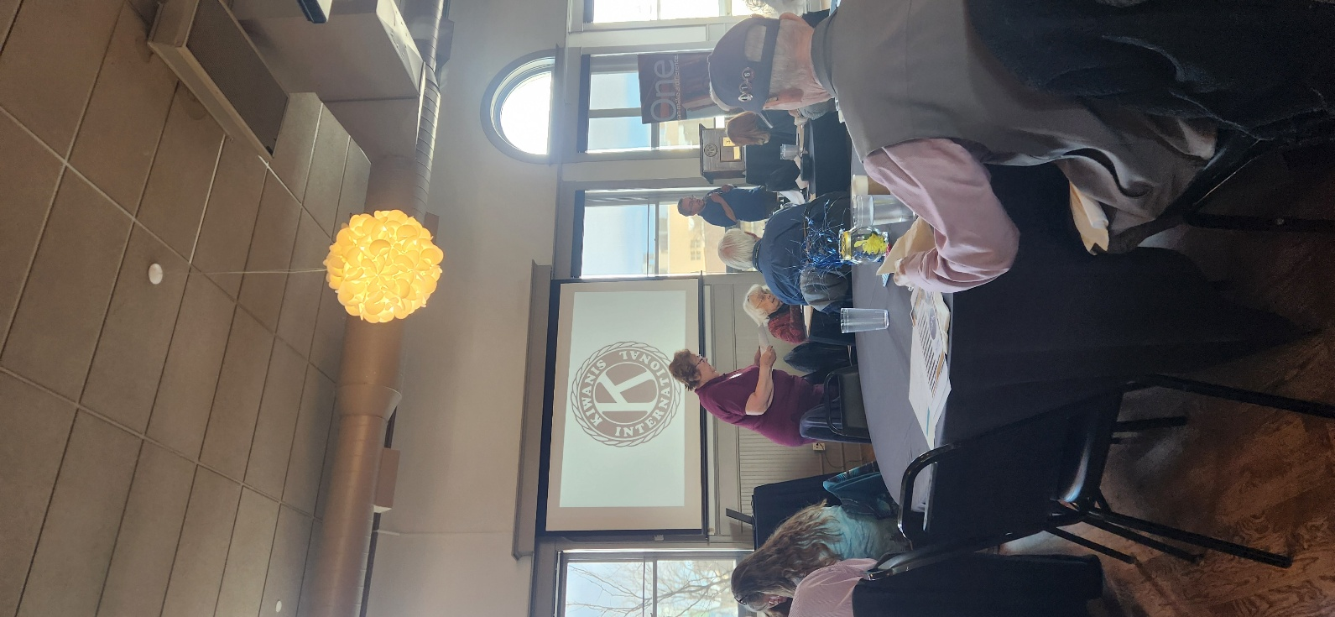**2025 Rocky Mountain District Spring Leadership Conference**

**— Matt Frederick**

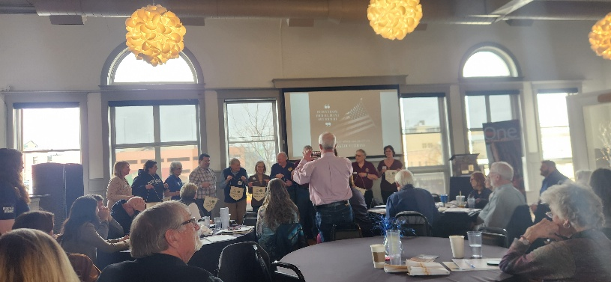Over 100 attendees from over 40 RMD clubs attended. Meeting was opened by Governor Kathy Williams. The 1st presenter was MacKenzie Carrol from Kiwanis International. She spoke about new ways to organize and accept fund raising through digital finance channels. Next was Chris Scutaro & Carol Wallace to help remind groups of grant funding that clubs are missing out on. We then broke off into groups to talk about different topics. We were able to listen to presenters about signature projects, branding and fundraising. Next we heard pitches from Dom and Andrea (picture top) advocationg for votes to be the next district governor. We then heard of various leadership postings that are needed to be filled at district level. We were able to hear from the local Key Club president, who is running for international president. We also celebrated a dozen clubs for being 100 years old. (lower picture)

The meeting was finished by Makenzie again speaking on how to use AI with club ideas and strategies for building and retaining your club.

\_\_\_\_\_\_\_\_\_\_\_  
Hope to ger more info from other attendees for next newsletter.

**Colorado Feeding Kids event**  
Four Club Kiwanians and two spouses joined many more dozens in Aurora last Saturday, April 5, to pack thousands of meals for Colorado Feeding Kids. Always a great event. More details in next newsletter.

**Upcoming Community Service/Kiwanis Events**

Dan, Dex, Ashley, Jamie, and Alan

* **April 10, 2025 –** Young Life’s Fundraising Banquet at 6:30 pm at The Establishment
* **May 1, 2025 –** Annual Fundraising Gala for MyChoice at 12700 Sheridan Blvd, Broomfield, CO
* **June 25-28, 2025** - **Kiwanis International Convention, Pittsburgh**
* **July 2-6,** [**2025 - Key Club International Convention**](https://click.marketing.kiwanis.org/?qs=7f2e85a24fe3a9af567f141d6059d5b3d38a21ec61edc9602f9c9f54f04fd0060e1c88380c2fab6c551ed62f6bf37d60109c236bc73a3840), Orlando, Florida
* **August 15-17, 2025** – Kiwanis District Convention, estimated cost: $225 per member, Denver Tech Center

**KIWANIS: Serving the Children of the World!**